**Sprint 4 Plan**

**Product name:** Peergrader

**Team name**: Peergrader

**Sprint completion date:** Jun 4, 2024

**Revision number:** 2

**Revision date:** May 22, 2024

**Goal:**

Maximum total hours/story points per Sprint: 75

**User Stories:**

1. ~~User Story 4.1 [15 story points] As a student I want to be able to dispute a score.~~
2. ~~User Story 4.2 [30 story points] As an instructor I want to be able to sync grades with Canvas API.~~
3. ~~User Story 4.3 [20 story points] As an instructor and student I want to be able to notify students/get reminders about assignment deadlines and grades.~~
4. User Story 4.1 [15] As an instructor I want to be able to see the scores students have been given and what I lost points for and export to CSV.
5. User Story 4.2 [15] As an instructor I want to be able to have customization over course settings to suit my needs.

**Backlog**

1. User Story 3.2 [15 story points] As an instructor I want to be able to see the progress the class has made on turning in and grading.
2. User Story 3.3 [15 story points] As a student I want to be able to see the scores I have been given and what I lost points for.
3. User Story 3.4 [15 story points] As a student or teacher I want to be able to customize my profile.

**Tasks Listing:**

User Story 4.1

* Display the breakdown of the student’s scores by student
* Show which rubric rows were selected by each student
* Show the comments/feedback from other students
* Export grades to CSV

User Story 4.2

* Add more settings to the create course page.
* Redo the UI

User Story 3.2

* Display a progress bar
* Display all the students and their current progress

User Story 3.3

* Display the breakdown of the student’s scores by student
* Show which rubric rows were selected by each student
* Show the comments/feedback from other students

User Story 3.4

* Create a profile page
* Change name
* Change picture
* Delete account

**Infrastructure:**

* Postgresql database: Supabase
* Storage (files): Supabase
* Deployment: Vercel
* GitHub: Version control
* Framework: next.js

**Team roles:**

* Christian Knab: Product owner
* Aastha Verma: SCRUM Master
* Eliah Reeves: Team member
* Eric Chuang: Team member

**Initial task assignment:**

* Aastha Verma: User Story 3.3, 4.1 UI for pages & polish UI on other pages
* Eliah Reeves: User Story 4.1 Student score export
* Christian Knab: User Story 3.4, 4.2 Polish profile page & add photo
* Eric Chuang: User Story 4.1 Compute the student’s score

**Burnup Chart:**

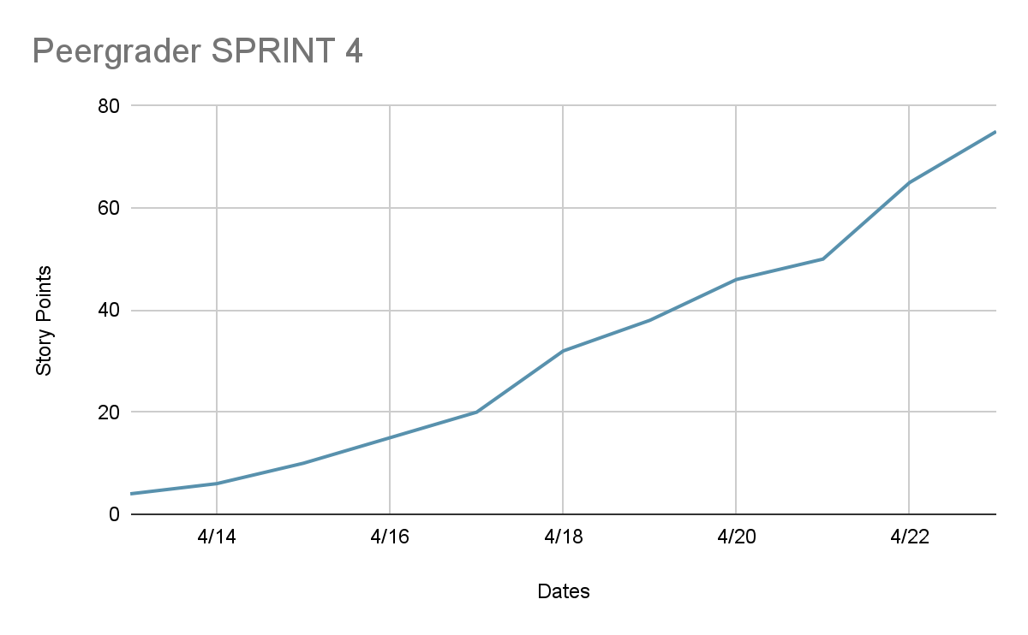

**SCRUM board**

| **User Story** | **Not Starter** | **In Progress** | **Done** |
| --- | --- | --- | --- |
| As an instructor I want to be able to see the scores students have been given and what I lost points for and export to CSV. | Export grades to CSV | Display the breakdown of the student’s scores by student  Show which rubric rows were selected by each student  Show the comments/feedback from other students |  |
| As an instructor I want to be able to have customization over course settings to suit my needs. |  | Add more settings to the create course page.  Redo the UI |  |
| As an instructor I want to be able to see the progress the class has made on turning in and grading. |  | Display a progress bar  Display all the students and their current progress |  |
| As a student I want to be able to see the scores I have been given and what I lost points for. |  | Display the breakdown of the student’s scores by student | Show which rubric rows were selected by each student  Show the comments/feedback from other students |
| As a student or teacher I want to be able to customize my profile. | Remove yourself from a class  Delete account | Change picture  Display profile across website | Create a profile page  Change name |

**Schedule of Scrum meetings**

* When: Mon/Wed/Fri 9am-11am
* Where: Jack’s Lounge Baskin Engineering
* TA meeting: Monday 11-12pm ZOOM